Title: Health and Safety Boarding Card 2015-16: Quiz questions

Question 1: Which of the following are suitable types of footwear for the lab?
A | 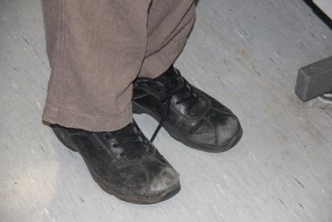 | B | 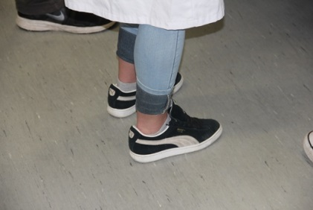
C | 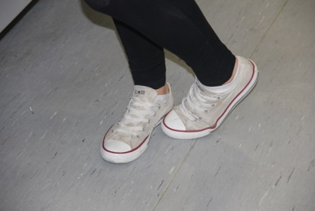 | D | 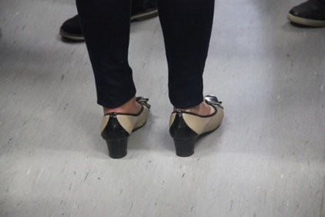
E | 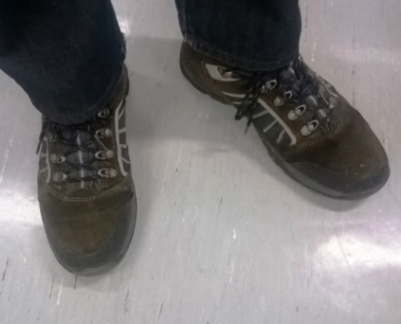 | F | None of the above

Question 2: Fill in the blanks

I should try to arrive at the lab 10 minutes , wearing my lab and safety (where appropriate). If the lab requires these items and I am not wearing them, I will be asked to the lab.

Question 3: Which of the following is the correct way to hold a bottle?
A | 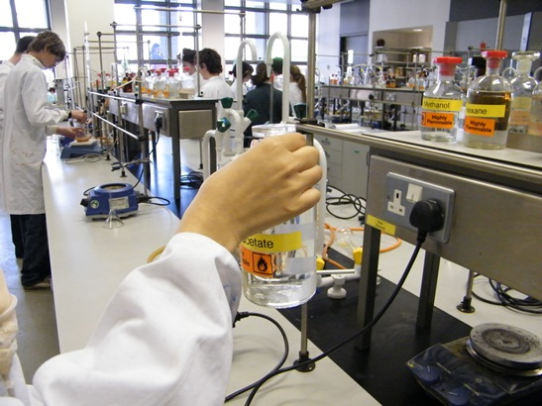 | B | 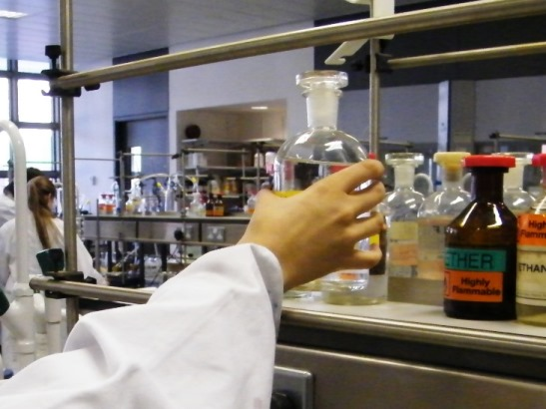
C | 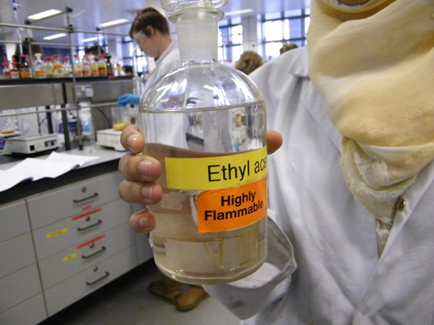 | D | None of the above

Question 4: Where should you grasp the filler when fitting a pipette?
 | A | Blue Arrow
 | B | Red Arrow
 | C | Green Arrow
 | D | None of the above

Question 5: Sign Colour Code (Fill in the blanks)

The colours of various signs have significance:

signs tell you what to do,

signs tell you what not to do,

signs tell you where to go,

signs give you a warning

Question 6: What is the meaning of these pictograms:

Question 7: If you or a colleague has an accident, what should you always do (tick one box)?

Pretend the accident didn't happen

Go and use the safety equipment yourself

Contact a member of staff immediately

Tell the lab staff after the lab has finished

Question 8: If the fire alarm goes off what should you do (tick one box)?

Run out of the lab as fast as your legs can carry you

Calmly follow the staff members out of the lab and go directly to the assembly point

Ignore it and continue working

Gather together your belongings before going to the assembly point
Question 9: Assembly points (fill in the blanks below)

On the map, the blue dot is Assembly Point, the red dot is Assembly Point , and the green dot is Assembly Point .

Question 10: What is the college emergency phone number (tick one box)?

9999

1112

1999

9112

Question 11: What is wrong with this photo (tick one box)?

I don't see anything wrong

Labels not legislative compliant

Something with the Acute Toxicity symbol is out on the bench

These chemicals should not be stored on a bench shelf

Labels not facing out

Question 12: What's wrong with this photo (tick one box)?

Label upside down

Label not legislation compliant

Can't see stopper

I don't see anything wrong

Question 13: What's wrong in this photo (tick one box)?

Person is kneeling down

Person is using a graduated cylinder

I don't see anything wrong

Gloves don't meet lab coat

Question 14: What is wrong in this photo (tick one box)?

Whoever owns the green hoodie has no fashion sense

Bags should not be there

My belongings could get stolen

I don't see anything wrong

